**Assignment Cover Sheet**

|  |  |  |
| --- | --- | --- |
| **Student Information (For group assignment, please state names of all members)** | | **Grade/Marks** |
| **Name** | **ID** |  |
| Fatima Binte Faiz Adreeta | B1901898 |  |
| Sivanesan Anthony | B1602199 |  |
|  |  |  |
|  |  |  |
|  |  |  |
|  |  |  |
|  |  |  |

|  |  |  |
| --- | --- | --- |
| **Module/Subject Information** | | **Office Acknowledgement** |
| **Module/Subject Code** | BIT216 |  |
| **Module/Subject Name** | Software Engineering Principles |  |
| **Lecturer/Tutor/Facilitator** | Seetha Letchumi |  |
| **Due Date** | 1st April 2022 |  |
| **Assignment Title/Topic** | Design and Testing Document  Prototype 2 |  |
| **Intake (where applicable)** | Semester 1, 2022 |  |
| **Word Count** |  | **Date/Time** |

**Declaration**

* I/We have read and understood the Programme Handbook that explains on **plagiarism**, and I/we testify that, unless otherwise acknowledged, the work submitted herein is entirely my/our own.
* I/We declare that no part of this assignment has been written for me/us by any other person(s) except where such collaboration has been authorized by the lecturer concerned.
* I/We authorize the University to test any work submitted by me/us, using text comparison software, for instances of plagiarism. I/We understand this will involve the University or its contractors copying my/our work and storing it on a database to be used in future to test work submitted by others.

Note: 1) The attachment of this statement on any electronically submitted assignments will be deemed to have the same authority as a signed statement.

2) The Group Leader signs the declaration on behalf of all members.

|  |  |
| --- | --- |
| Signature: Fatima Binte Faiz Adreeta, Sivanesan Anthony | Date: 28/03/2022 |
| E-mail:b1901898@helplive.edu.my; b1602199@helplive.edu.my |  |

|  |
| --- |
| **Feedback/Comments\*** |
| **Main Strengths** |
|  |
|  |
|  |
|  |
|  |
|  |
|  |
| **Main Weaknesses** |
|  |
|  |
|  |
|  |
|  |
|  |
|  |
| **Suggestions for improvement** |
|  |
|  |
|  |
|  |
|  |
|  |
|  |

|  |  |
| --- | --- |
|  | **Student acknowledge feedback/comments** |
|  |
| Grader’s signature | Student’s signature: |
| Date: | Date: |

Note:

1. A soft and hard copy of the assignment shall be submitted.
2. The signed copy of the assignment cover sheet shall be retained by the marker.
3. If the Turnitin report is required, students have to submit it with the assignment. However, departments may allow students up to **THREE** (3) working days after submission of the assignment to submit the Turnitin report. The assignment shall only be marked upon the submission of the Turnitin report.

*Use additional sheets if required.

Table of Contents

Introduction: 5

Modifications from previous assignments : 5

Updated Class Diagram 5

Use case 1: Manage Organization 5

Updated Expanded Use Case 5

Updated SSD and Contracts: 6

Use case 2: Register Applicant 8

Updated Expanded Use Case 8

Updated Contracts 9

New SSD and Contracts 9

Use case 3: Organize aid Appeal 10

Updated SSD and Contracts: 10

Use case 4: View Appeals 11

Updated Expanded Use Case 11

Updated SSD and Contracts 12

Justification 13

# Introduction:

This assignment is a continuation of Assignment 1 and 2 regarding creating a reliable system for HELP-Aid. The name of our system is HELP-Aid Contact Portal which aims to create a portal of effective communication between the HELP-Aid Admin, the organizations, the applicants and the donors. In this assignment, we implement and test our iteration 2 and fix the problems of our iteration 1 according to user requirements and lecturer feedback.

# Modifications from previous assignments :

# Updated Class Diagram

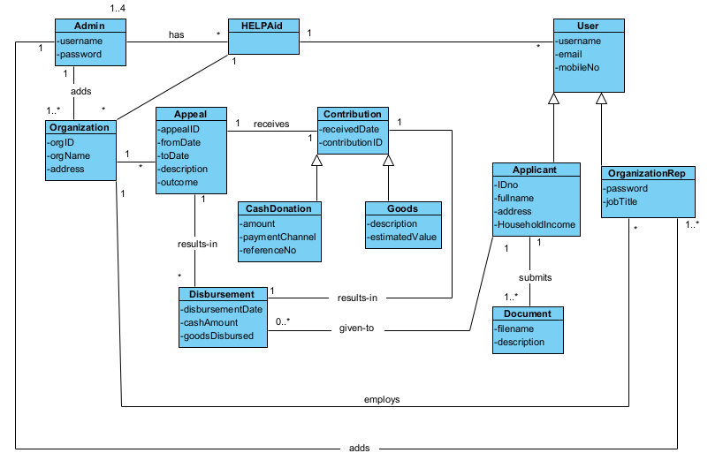

# Use case 1: Manage Organization

## Updated Expanded Use Case

|  |  |  |
| --- | --- | --- |
| Use Case 1 | Manage Organization | |
| Goal in Context | To allow the HELP Aid Admin to manage Organizations and their representatives. | |
| Primary Actor | HELP Aid Admin | |
| Trigger | The HELP Aid Admin wants to manage organization details | |
| **Typical Course of Events Actor Action** | | **System Response** |
| 1. This use case begins when an HELP Aid Admin wants to manage organizations in the system | |  |
| 1. The HELP Aid Admin logs in with valid username and password | |  |
| 1. Admin adds a new Organization with Organization name and Address | | Organization ID is auto-generated. |
| 1. Admin views the Organization List to check his entry | | A list of all the Organization of the system is shown |
| **Alternative Course of Events** | | |
| Line 3a. If Organization exists, cancel the use case. | | |
| Line 3b. If the Admin wants to add an Organization Representative for a Organization into the system, he enters username, password, mobile no and job title for the Organization Representative. If Organization exists, the representative is recorded and linked to Organization. If Organization does not exist, add the Organization. | | |
| Line 4a. Admin views the Representative List to check his entry. A list of all the representatives along with their organization name is shown | | |

## Updated SSD and Contracts:

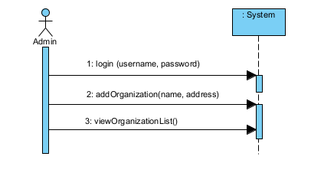

|  |  |
| --- | --- |
| Name | login (username, password) |
| Responsibilities | To let HELP-Aid Administrator log in to the system. |
| Pre-conditions | HELP-Aid object must exist  Admin object must exist |
| Post-conditions | Admin logs in to the system. |

|  |  |
| --- | --- |
| Name | addOrganization(name, address) |
| Responsibilities | To let HELP-Aid Admin add a new organization to the system. |
| Pre-conditions | Organization Object must not exist  HELP-Aid Object must exist |
| Post-conditions | Name and address of Organization is recorded based on input parameters.  Organization ID is auto-generated.  Organization object is created.  Organization object is linked to HELP-Aid object. |

|  |  |
| --- | --- |
| Name | viewOrganizationList() |
| Responsibilities | To let HELP-Aid admin view the list of organizations added to the system |
| Pre-conditions | Organization Object must exist  HELP-Aid admin must exist |
| Post-conditions | A list of organizations in the system is shown with Organization name, address and Organization ID. |

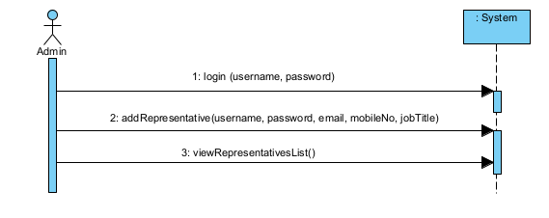

|  |  |
| --- | --- |
| Name | login (username, password) |
| Responsibilities | To let HELP-Aid Administrator log in to the system. |
| Pre-conditions | HELP-Aid object must exist  Admin object must exist |
| Post-conditions | Admin logs in to the system. |

|  |  |
| --- | --- |
| Name | addRepresentatives(username, password, email, mobileNo, jobTitle) |
| Responsibilities | To let HELP-Aid Admin add new Representative for an existing organization |
| Pre-conditions | Organization Rep object must not exist  Organization object must exist  HELP-Aid object must exist |
| Post-conditions | Username, password, email, mobileNo, jobTitle of Organization Rep is recorded based on input parameters.  Username is set as primary key  Organization Rep object is created.  Organization Rep object is linked to Organization Object.  Organization object is linked to HELP-Aid object. |

|  |  |
| --- | --- |
| Name | viewRepresentatives() |
| Responsibilities | To let HELP-Aid admin view the list of Organization representatives added to the system |
| Pre-conditions | Organization Rep object must exist  Organization object must exist  HELP-Aid object must exist |
| Post-conditions | A list of representatives is shown with their username, organization name and job title |

# Use case 2: Register Applicant

## Updated Expanded Use Case

|  |  |  |
| --- | --- | --- |
| Use Case 2 | Register Applicant | |
| Goal in Context | To allow the Organization Representative to register Aid Applicants | |
| Primary Actor  Secondary Actor | Organization Representative  Aid Applicant | |
| Trigger | The Organization Representative wants to record a new applicant, or the applicant wants to register under an organization. | |
| **Typical Course of Events Actor Action** | | **System Response** |
| 1. This use case begins when an Organization Representative wants to register an Aid Applicant who has come to the Organization’s premises. | |  |
| 1. The Organization Representative logs in with a valid username and password. | | The organization rep’s name is shown. |
| 1. The Organization Representative enters the full name, ID, address, household income of the aid applicant. | | The Aid Applicant is recorded for the organization. |
| 1. The Organization Representative uploads a document with the Aid Applicant’s proof of household income by entering the filename and description. | | The document is recorded for the Aid Applicant. |
| **Alternative Course of Events** | | |
| Line 1a. If the Aid Applicant is able to register themselves online, the Aid Applicant selects an organization from the list of organizations, then skip to line 3 to complete the registration. An Applicant can only be recorded with one organization. | | |
| Line 4a. If there are additional documents, repeat line 4. | | |

## Updated Contracts

|  |  |
| --- | --- |
| Name | addAidApplicant (IDno, fullName, email, mobileNo, address, householdIncome) |
| Responsibilities | To register an Aid Applicant to the system |
| Pre-conditions | Applicant object must not exist  HELP-Aid object must exist |
| Post-conditions | Applicant's ID, fullName, email, mobileNo, address, householdIncome is recorded.  Applicant object is created.  Applicant object is linked to HELP-Aid object. |

|  |  |
| --- | --- |
| Name | addDocument (filename, description) |
| Responsibilities | To upload a document as proof of Aid Applicant's household income |
| Pre-conditions | Applicant object must exist.  Document object must not exist. |
| Post-conditions | Filename and description are recorded.  Filename is set as primary key.  Document object is created.  Document object linked to Applicant object. |

## New SSD and Contracts

(Disclaimer: The new SSD+Contracts is an extension of the updated SSD and Contracts submitted in Assignment 1. No modification was needed to the already submitted SSD+Contracts for this use case. The new SSD+Contracts shows how an applicant will self-register, where the previous SSD+Contracts showed how an organization rep will register an applicant.)

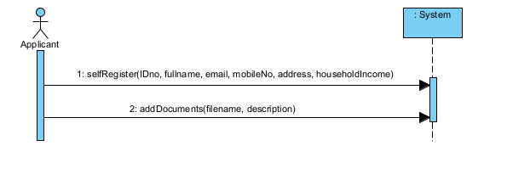

|  |  |
| --- | --- |
| Name | selfRegister (IDno, fullName, email, mobileNo, address, householdIncome) |
| Responsibilities | To allow an applicant to self-register to the system |
| Pre-conditions | Applicant object must not exist  HELP-Aid object must exist |
| Post-conditions | Applicant's ID, fullName, email, mobileNo, address, householdIncome is recorded.  Applicant object is created.  Applicant object is linked to HELP-Aid object. |

|  |  |
| --- | --- |
| Name | addDocument (filename, description) |
| Responsibilities | To upload a document as proof of Aid Applicant's household income |
| Pre-conditions | Applicant object must exist.  Document object must not exist. |
| Post-conditions | Filename and description are recorded.  Filename is set as primary key.  Document object is created.  Document object linked to Applicant object. |

# Use case 3: Organize aid Appeal

## Updated expanded use case

|  |  |  |
| --- | --- | --- |
| Use Case 3 | Organize Aid Appeal | |
| Goal in Context | To allow the Organization Representative to record a new appeal for Aid. | |
| Primary Actor  Secondary Actor | Organization Representative | |
| Trigger | The Organization Representative wants to record a new appeal for aid. | |
| **Typical Course of Events Actor Action** | | **System Response** |
| 1. This use case begins when an Organization Representative wants to record a new appeal for aid. | |  |
| 1. The Organization Representative logs in with a valid username and password. | | The organization name is shown. |
| 1. The Organization Representative enters the from date, to date and description and outcome of the appeal. | | The appealID is automatically generated. |

## Updated SSD and Contracts:

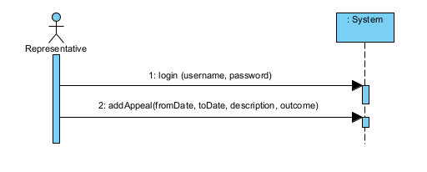

|  |  |
| --- | --- |
| Name | login (username, password) |
| Responsibilities | To let Organization Representative log in to the system. |
| Pre-conditions | Organization object must exist  OrganizationRep object must exist |
| Post-conditions | Organization rep logs in to the system.  The Organization Representative’s name is generated. |

|  |  |
| --- | --- |
| Name | addAppeal (fromDate, toDate, description, outcome) |
| Responsibilities | To add an appeal to collect donations. |
| Pre-conditions | Organization object must exist  Appeal object must not exist |
| Post-conditions | Appeal’s fromDate, toDate, description is recorded according to input parameters.  Outcome is set to “ACTIVE”.  Appeal ID is auto-generated.  Appeal object is created.  Appeal object is linked to Organization object.  Appeal object is linked to HELP-Aid object. |

# Use case 4: View Appeals

## Updated Expanded Use Case

|  |  |  |
| --- | --- | --- |
| Use Case 4 | View Appeals | |
| Goal in Context | To allow Donors to view appeals for Aid | |
| Primary Actor | Donor | |
| Trigger | A Donor wants to check if there are any appeals | |
| **Typical Course of Events Actor Action** | | **System Response** |
| 1. This use case begins when a Donor wants to check if there are any appeals | | . |
| 1. The Donor visit the appeal page | | A list of appeals is shown with the from date, to date and description. |
| 1. The Donor selects one of the appeals. | | A donation form is generated and Appeal ID, Organization name and Appeal Description is shown |
| **Alternative Course of Events** | | |
| Line 2a. The Donor may select to view past appeals. The from date, to date, description and outcome is shown. | | |
| Line 3a: if the Donor does not select an appeal, cancel the use case. | | |
| Line 3b: if the donor does not fill up the donation form, cancel the use case. | | |

## Updated SSD and Contracts

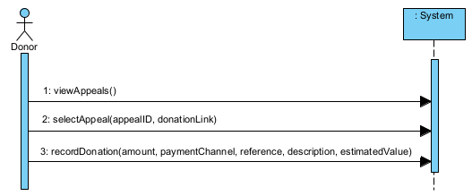

|  |  |
| --- | --- |
| Name | viewAppeals() |
| Responsibilities | To display a list of current and past appeals |
| Pre-conditions | Appeal objects must exist. |
| Post-conditions | A list of current and past appeals is displayed.  fromDate, toDate, description, outcome, donation link of all the appeals is shown. |

|  |  |
| --- | --- |
| Name | recordDonation(amount, paymentChannel, reference, description, estimatedValue) |
| Responsibilities | To record donation for a particular appeal |
| Pre-conditions | Appeal objects must exist.  Appeal outcome must be “ACTIVE”  Donation links must be “Available” |
| Post-conditions | Donation page for selected appeal is generated.  AppealID, Organization name and Appeal description is shown.  The amount, paymentChannel, reference, description, estimatedValue is recorded according to input parameters.  Appeal outcome is set to “NOT ACTIVE” and the donation inputs are are visible as “Contribution Details” of Appeal outcome. |

## Justification

From the previous View Appeals use case, it was unclear how View appeals was related to Donor’s donation and eventually lead Organization rep to record the donation as Contributions in the Record Contribution use case. Because for Organization Representative to record any kind of donation by the donor, the donation details must be recorded. So, in the updated Expanded and SSD we tried to explain the flow of logic and data from View appeals to Record Contribution.

# Use Case 5: Record Contribution

## Updated Expanded Use Case

|  |  |  |
| --- | --- | --- |
| Use Case 5 | Record Contribution | |
| Goal in Context | To record contributions from Donors. | |
| Primary Actor | Organization Representative  Donor | |
| Trigger | A Donor wants to make a contribution, either online or at the organization’s premises. | |
| **Typical Course of Events Actor Action** | | **System Response** |
| 1. This use case begins when a Donor wants to make a contribution. | | . |
| 1. The Organization Representative logs in with a valid username and password. | | The organization name is shown with a list of current appeals and their outcomes. |
| 1. The Organization Representative selects the appeal ID for the contribution. | | The from date, to date of the appeal and the current date is shown. |
| 1. The Organization Representative records the description and estimated value of the goods. | | The Goods contribution is recorded for the appeal. A contributionID is generated and receivedDate is set to the current date. |
| **Alternative Course of Events** | | |
| Line 2a: If the Donor is contributing cash through the payment provider, skip to line 3. | | |
| Line 4a. If the Donor is contributing cash, the cash amount, payment channel and referenceNo is recorded. A contribution ID is generated and the received date is set to the current date. | | |

Updated SSD and Contracts

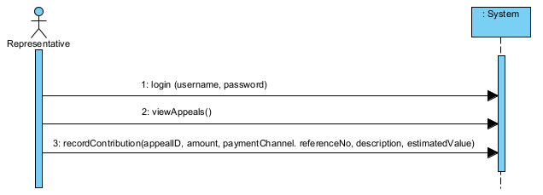

|  |  |
| --- | --- |
| Name | login (username, password) |
| Responsibilities | To let Organization Representative log in to the system. |
| Pre-conditions | Organization object must exist  Organization Rep object must exist |
| Post-conditions | Organization rep logs in to the system.  The Organization Representative's name is generated. |

|  |  |
| --- | --- |
| Name | viewAppeals() |
| Responsibilities | To allow Organization Representative to view all the appeals with contribution details. |
| Pre-conditions | Appeals object must exist |
| Post-conditions | A list of appeals with their fromDate, toDate, description, outcome and contribution form link is shown. |

|  |  |
| --- | --- |
| Name | recordContribution(appealID, amount, paymentChannel. referenceNo, description, estimatedValue) |
| Responsibilities | To allow Organization Representative to record contribution given to an appeal. |
| Pre-conditions | Appeal Object must exist.  Appeal Outcome must be “NOT ACTIVE” with contribution details.  Contribution object must not exist. |
| Post-conditions | Contribution amount, paymentChannel. referenceNo, description, estimatedValue is set based on input parameters  appealID is set as foreign key.  Contribution ID is auto generated.  Contribution object is created.  Contribution object is linked to Appeal object. |

# Use case 6: Record Disbursements

## Updated Expanded Use Case

|  |  |  |
| --- | --- | --- |
| Use Case 6 | Record Aid Disbursement | |
| Goal in Context | To record disbursement of aid to applicants. | |
| Primary Actor | Organization Representative | |
| Trigger | The Organization Representative wants to record aid that has been disbursed. | |
| **Typical Course of Events Actor Action** | | **System Response** |
| 1. This use case begins when the Organization Representative wants to record the disbursement of aid. | |  |
| 1. The Organization Representative logs in with a valid username and password. | | The organization's name is shown with a list of current and past appeals. |
| 1. The Organization Representative selects the appeal ID. | | The from date and to date of the appeal is shown, together with the list of contributions and the details of the contributions. |
| 1. The Organization Representative selects to view Applicants. | | A list of Applicants registered with the Organization is shown. |
| 1. The Organization Representative selects the IDno of an applicant. | | The applicant’s name, address and household income is shown. |
| 1. The Organization Representative enters the disbursement date, cash amount and the goods to be provided to the applicant. | | The disbursement is recorded for the Applicant. |
| 1. The Organization Representative records the outcome of the Appeal. | | The appeal outcome is set to “ACTIVE” |
| **Alternative Course of Events** | | |
| Line 5a. The Organization Representative may choose to view the Applicant’s documents. | | |
| Line 6a. If there are additional disbursements to applicants, repeat lines 5 and 6. | | |

Updated Contract

|  |  |
| --- | --- |
| Name | recordDisbursement(disbursementDate, cashAmount, goodsDisbursed) |
| Responsibilities | To record the disbursement of a donation to an applicant |
| Pre-conditions | Applicant object must exist  Appeal object must exist  Appeal outcome must be “NOT ACTIVE” with contribution details  Disbursement object must not exist |
| Post-conditions | disbursementDate, cashAmount, goodsDisbursed are recorded.  Disbursement ID is auto-generated.  Disbursement object is created.  Disbursement object linked to Applicant object.  Disbursement object linked to Appeal object. |

# Updated ERD

Rectangle - Class/Object

Double Rectangle - Weak object (Object whose existence is nothing on its own)

Diamond - relationship

Oval - Class primary key

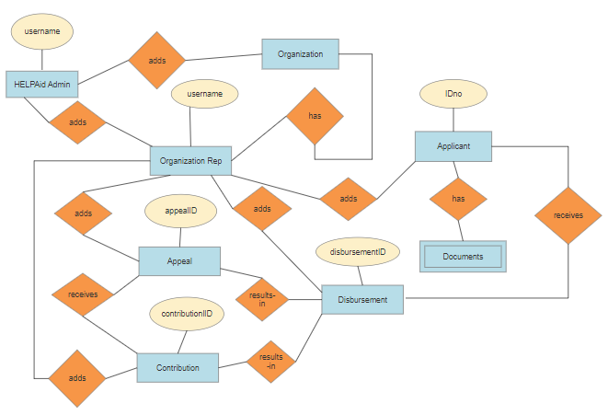

Updated Data Dictionary